

ECE103

Durid - Nawar - Abdulrhman Project ECE103-2023

I-V Curve - Spring 2023

Amro Yousef- S21207539

Tariq tadmori -S21207550

Layan Turkistani-S22107664

Aven Nabi - S21106972

Instructor: Narjisse Kabbaj

Narjisse Kabbaj 2 Effat University

Durid - Nawar - Abdulrhman Project ECE103-2023

Contents

1 Abstract:

2

2 Introduction: 2

3 Methodology: 2

3.1 Part A First output:. . . . . . . . . . . . . . . . . . . . . 3

3.2 Part B Final output: . . . . . . . . . . . . . . . . . . . 4

4 Problem and Learning Outcomes: 5

4.1 1-Problem: . . . . . . . . . . . . . . . . . . . . . . . . 5

4.2 2-Learning Outcome: . . . . . . . . . . . . . . . . . . . 5

5 Teamwork and Time Management 5

6 Conclusion 6

Narjisse Kabbaj 1 Effat University

Durid - Nawar - Abdulrhman Project ECE103-2023

1 Abstract:

This project was created by Durid Al Masri,Nawar Alimam ,and Abdulrhman Alhuwiti.Our code utilizes a mathematical model to determine the current-voltage (I-V) behaviour of a solar cell. By considering factors such as temperature and irradiance, the model solves equations using a numerical method. The resulting I-V curves are graphically represented using Gnuplot, providing a visual representation for two distinct irradiance levels.

2 Introduction:

Our code focuses on determining the current-voltage (I-V) behaviour of a photovoltaic (PV) cell, which is essential for assessing its performance under various conditions. By utilizing a mathematical model, the code calculates the I-V characteristics by considering the influence of temperature and irradiance. To solve the equations, a numerical method (Newton-Raphson) is employed, and the resulting I-V curves are plotted using Gnuplot. This allows for a visual representation of the I-V behaviour under two distinct irradiance levels.

3 Methodology:

Our methodology for this code involves several steps. It begins by reading data from a CSV file and prompting the user for specific inputs, such as time and a secondary irradiance value. The code then employs a mathematical model that accounts for temperature and irradiance conditions to calculate the I-V characteristics of the PV cell. To solve the equations, a numerical method is utilized, computing the current and voltage values for each point on the I-V curve. Lastly, the output is graphically presented using Gnuplot, providing a visual representation of the I-V curves for two distinct irradiance values.

Narjisse Kabbaj 2 Effat University

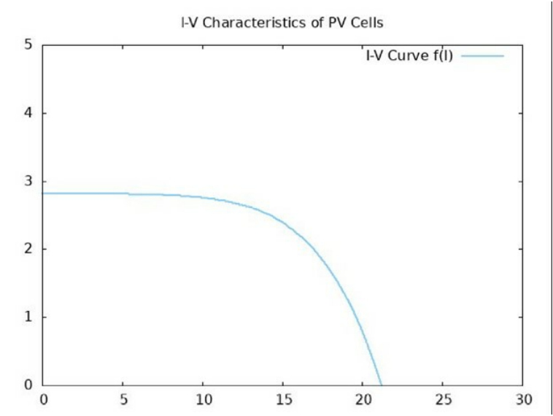

Durid - Nawar - Abdulrhman Project ECE103-2023

3.1 Part A First output:

Figure 1: Part A

Narjisse Kabbaj 3 Effat University

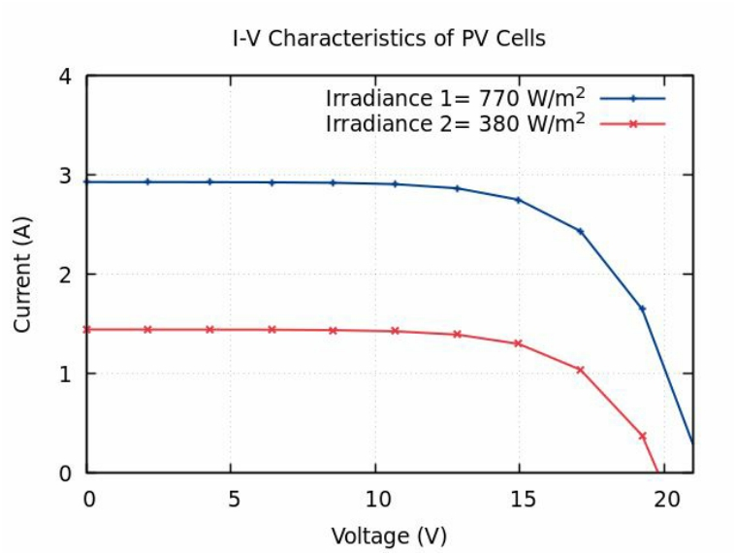

Durid - Nawar - Abdulrhman Project ECE103-2023

3.2 Part B Final output:

Figure 2: Part B

Narjisse Kabbaj 4 Effat University

Durid - Nawar - Abdulrhman Project ECE103-2023

4 Problem and Learning Outcomes:

4.1 1-Problem:

The I-V characteristics of a PV cell play a crucial role in assessing its performance under various condi- tions. This code addresses the problem of calculating the I-V curves by incorporating a mathematical model that considers temperature and irradiance factors. By utilizing a numerical method to solve the equations, the code provides valuable insights into the performance of the PV cell. The specific output of the code is the visualization of I-V curves for two distinct irradiance values, enabling a comprehensive understanding of the PV cell’s behavior under different conditions.

4.2 2-Learning Outcome:

By working with this code, users will gain an understanding of how to calculate the current-voltage (I-V) curves of a photovoltaic (PV) cell while considering temperature and irradiance conditions. They will learn to implement a mathematical model and utilize a numerical method to solve the equations. Additionally, users will become proficient in visualizing the I-V curves using Gnuplot.

5 Teamwork and Time Management

Tariq Tadmori 35%

Amro Yousef 21.6%

Layan Turkistani 21.6%

Aven Nabi 21.6%

Figure 3: teamwork

Narjisse Kabbaj 5 Effat University

Durid - Nawar - Abdulrhman Project ECE103-2023

6 Conclusion

To conclude, our code offers a possible technique for determining the I-V curves of a photovoltaic (PV) cell. By incorporating a mathematical model that accounts for temperature and irradiance conditions, the code calculates the I-V characteristics and utilizes Gnuplot for visual representation. The code is valuable for researchers and engineers in the renewable energy field as it enables the assessment of a PV cell’s performance under different conditions. Furthermore, the code can be enhanced to consider additional factors like shading and spectral effects, which can influence the PV cell’s performance, making it even more versatile and powerful.

Narjisse Kabbaj 6 Effat University